Code Hierarchy

In this chapter, an overall hierarchy, along with detailed code hierarchies will be demonstrated in three parts. Since the project is built based on React JavaScript Library, the code hierarchy follows the structure of components and scenes.

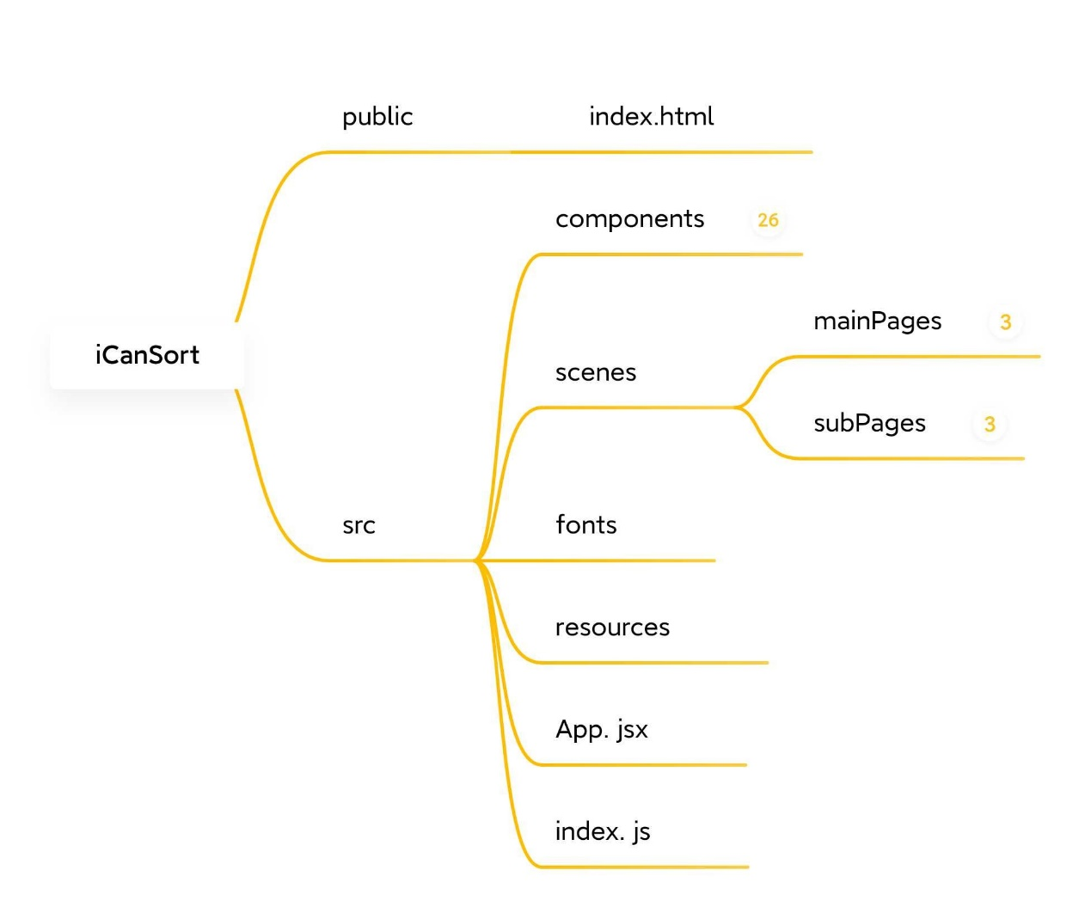

Figure1: Overall code hierarchy of the project

The root of the project consists of two folders, which are public and src. The public folder contains an HTML entrance for this web-based app. Src is the root directory for JavaScript code and other resources such as fonts and images. In the src folder, the components directory stores all basic components which are used to compose scenes. Scenes directory stores files that define each scene in the software. Fonts and resources stores fonts used and images in the software. App.jsx and index.js are two main entrance to launch the software.

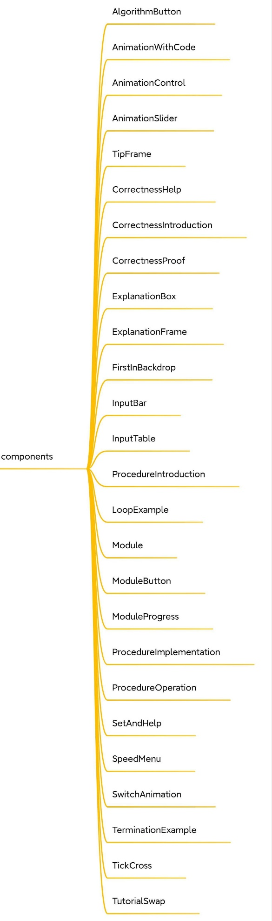

Figure2: Code hierarchy of components directory

The components directory contains all the basic components that functioned as subparts in software scenes. Components were built separately in order to make them reusable. This is also a feature of React as a JavaScript Library based on reusable components.

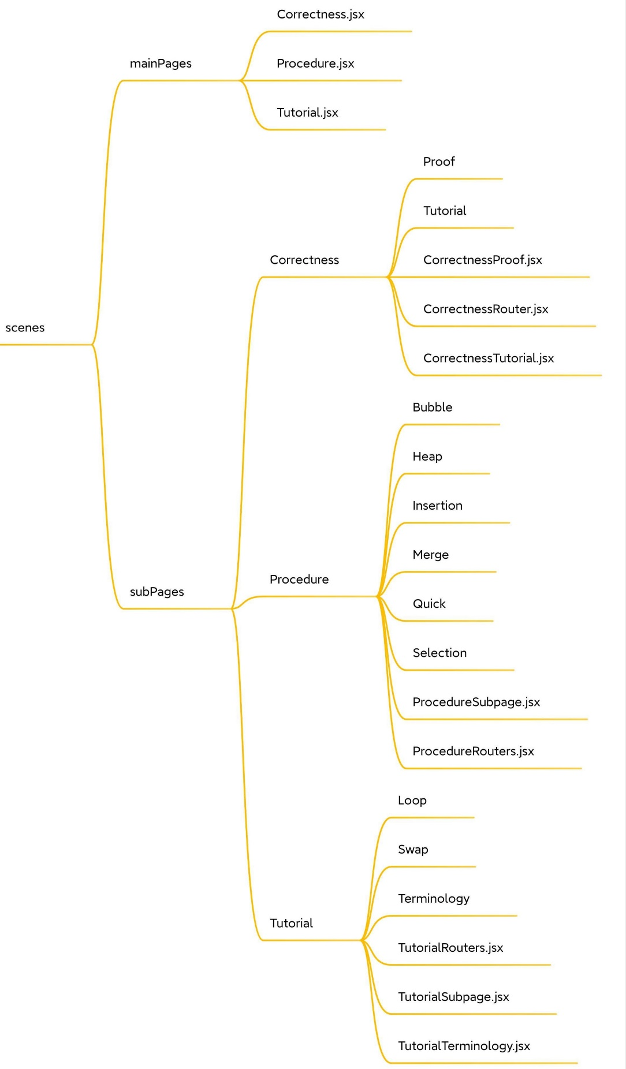

Figure3: Code hierarchy of scenes directory

The directory scenes contains mainPages and subPages. The mainPages refer to three sections Tutorial, Procedure and Correctness. The subPages consists of pages inside the three main sections. Each scene file defines how a specific page would be displayed in the software.